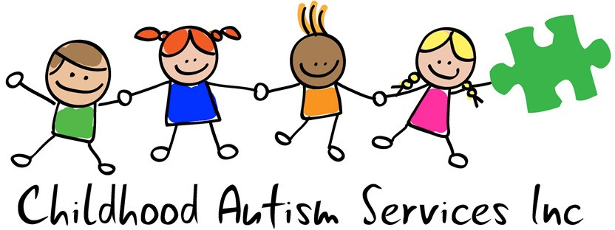

WHAT IS ABA?
What makes ABA effective?

The effectiveness of Applied Behavior Analysis lies in its foundation in scientific research that has been conducted in laboratories as well as the natural setting for decades. Also, data is continuously collected and reviewed on client success to evaluate the effectiveness of treatment. Another important component to success is the Individualized treatment packages that are created for each client to increase positive outcomes.

Applied Behavior Analysis

is a science focusing on understanding and improving human behavior by discovering environmental variables that reliably influence meaningful behavior

What makes ABA “different?”
- ABA evaluates how others interact with their physical environment vs internal events (e.g. thoughts)
- ABA only utilizes interventions and techniques based off of findings from peer-reviewed research
- ABA treatment is individualized per client and their families
- ABA focuses on treatment of behavior that has an impact on how an individual functions in the environment in which a child operates daily

ABA Myths
ABA only focuses on a child’s deficits
---------
ABA will turn my child into a robot.
---------
ABA is only used for individuals with autism.
---------
ABA and Psychology are the same thing.

Domains of focus in the field of Applied Behavior Analysis
- Social skills
- Adaptive Living
- Communication
- Play
- Maladaptive Behavior
- Family Guidance
- Motor Skills

Childhood Autism Services pg. 1

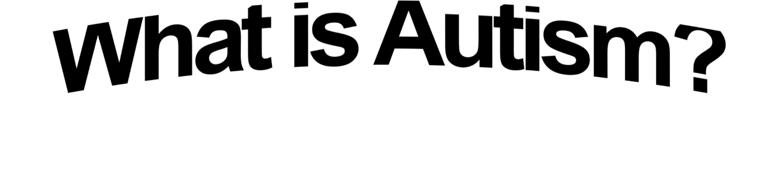
Childhood Autism Services pg. 2

Autism Spectrum Disorder (ASD)
Is defined according to the DSM-5 as it pertains to deficits in social communication and restricted, repetitive patterns of behavior, interests, or activities. Symptoms must be present in early childhood and together, limit everyday functioning.
Diagnosis of ASD starts around the age of 18-24 months individuals start to miss developmental milestones communication, motor delays and lack of social skills.
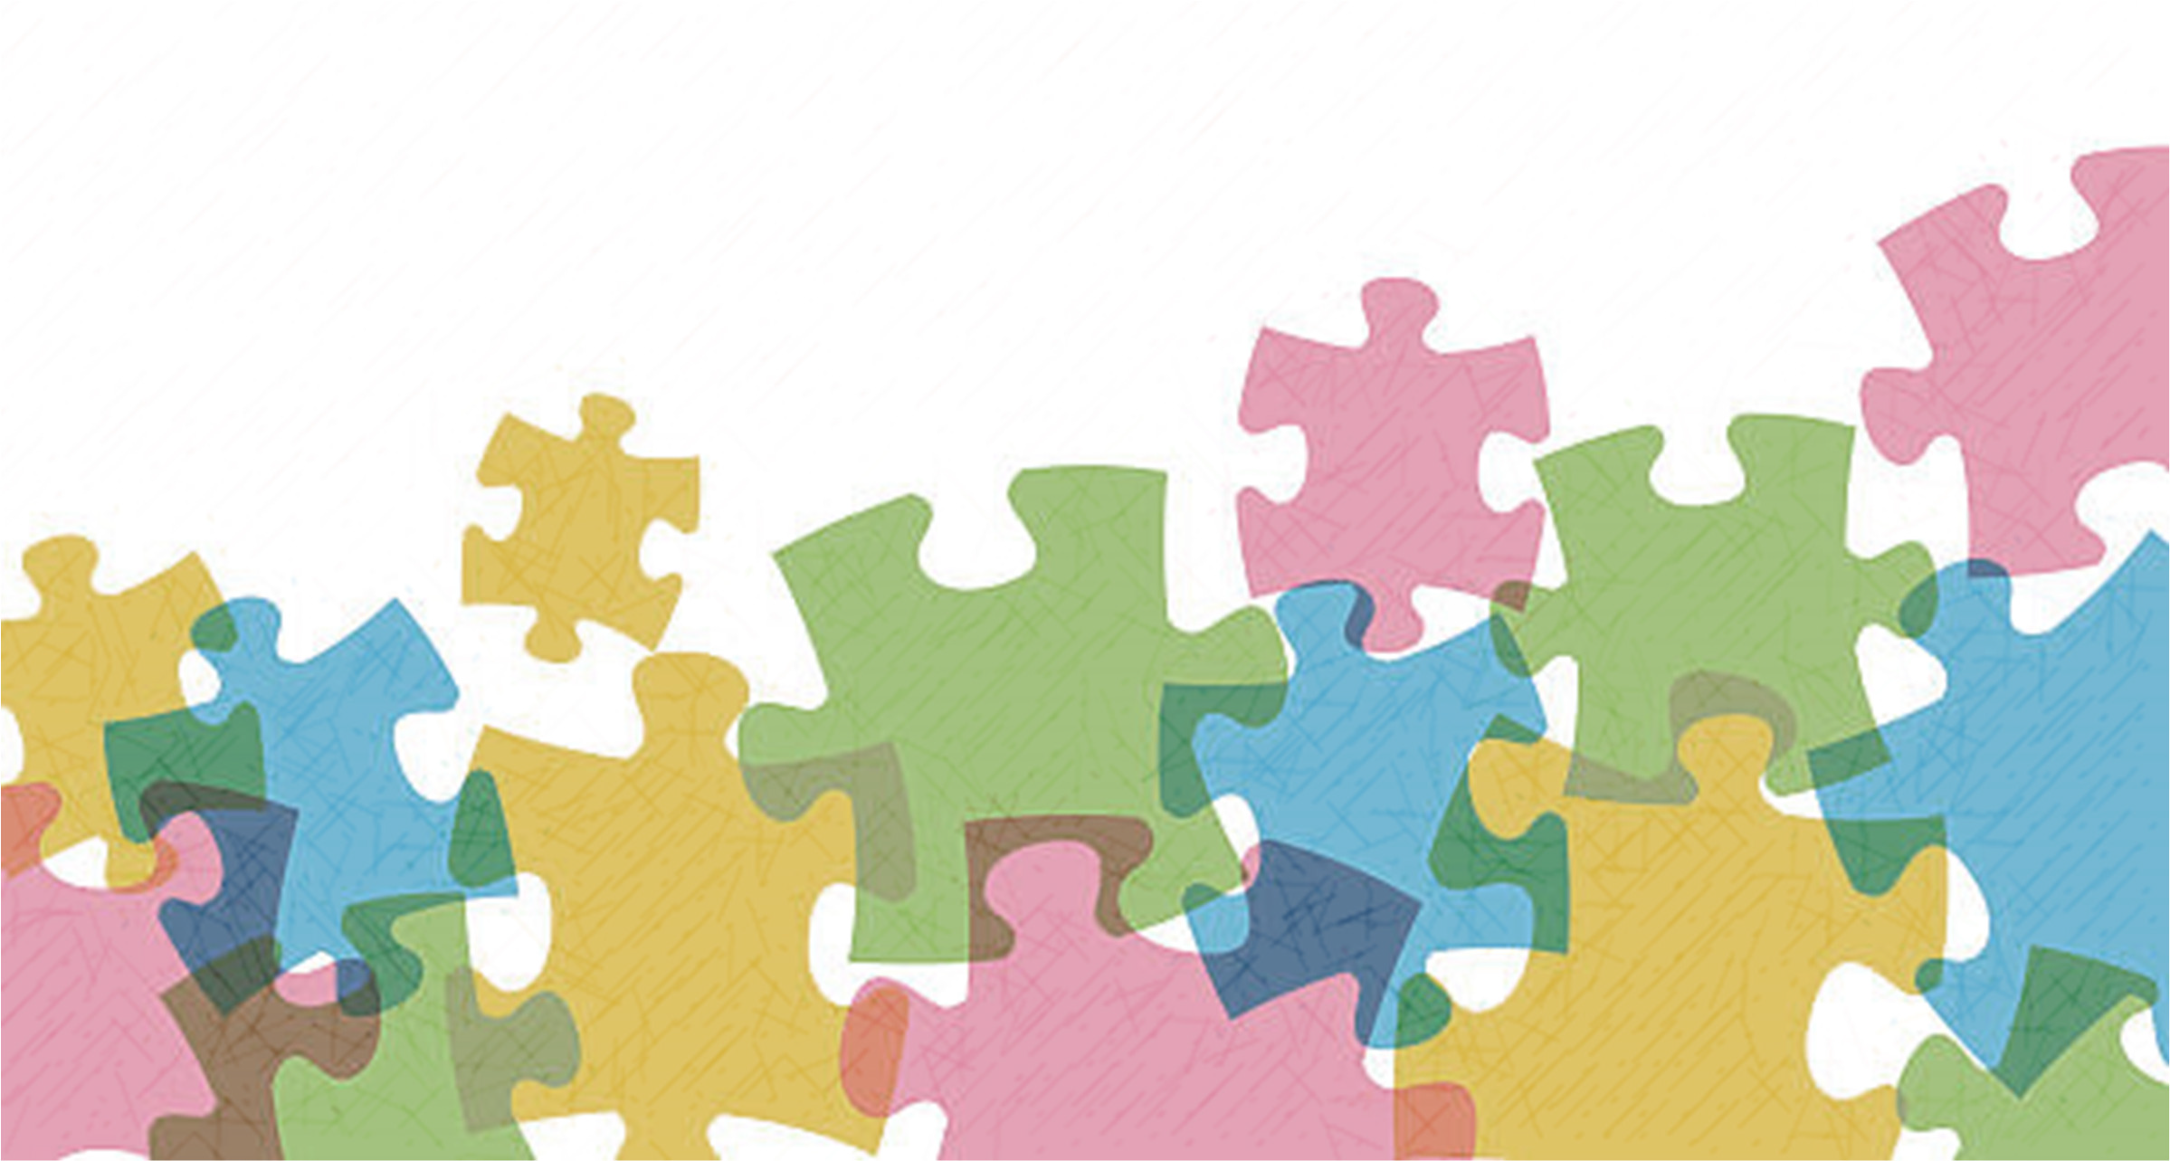
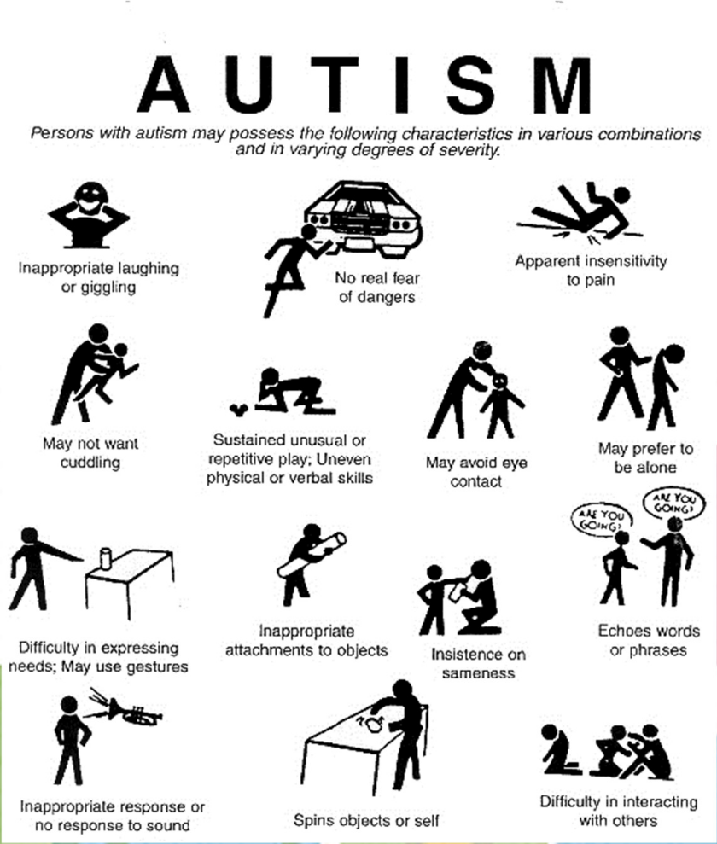
No two children with autism are exactly alike. Autism is said to be a spectrum, meaning, there are a range of levels of functioning within the autism community; some children may be lower functioning than others, and as such may display a different combination of skills than others.

What is the cause of ASD?
There is no known cause for autism, but it is generally accepted that it is caused by abnormalities in brain structure or function. Brain scans show differences in the shape and structure of the brain in children with autism compared to in neurotypical children.

What is the cure for ASD?
Frustrating to many, there is no known cure for Autism at this time. However, ABA has been shown through research, and over several years, to improve the quality of life of those diagnosed with ASD.

ABA LINGO
Behavior is the activity of a living organism. Human behavior is everything that people
do and is observable and measurable.

Board Certified Behavior Analyst (BCBA) | Registered Behavior Technician (RBT)
-Have their master’s degree in ABA or related field  -Have completed hundreds of supervised hours  -Have passed a test to obtain certification  -Have to complete continuing education courses every two years to maintain certification  Think of a BCBA like a physician. They have cases that they develop treatment for and monitor progress throughout the course of therapy. BCBAs train the RBTs to implement the treatment they ‘prescribe’ and collect evident on how effective that treatment is. The BCBAs review progress and make clinical decisions to make changes or continue the plan in place. Also, BCBAs collaborate with other professionals/individuals in their client’s life to ensure continuity of treatment. | -Have a minimum of a high school diploma  -Completed a 40-hour training  -Passed a test to obtain certification  Think of a RBT like a nurse. They have cases they work on and follow the programs written by the BCBA. They receive constant supervision and feedback on treatment implementation.  RBTs take data on the effectiveness of interventions for the BCBA to review.

Positive Reinforcement
- Positive reinforcement is when a stimulus occurs immediately after a behavior and then that behavior happens more often in the future.
- Example: A child asks his father for some candy multiple times. The father gives in and lets the child have the candy. If asking repeatedly for candy (or other desired items) happens more often in the future, then this is an example of positive reinforcement.

Negative Reinforcement
- Negative reinforcement is when a stimulus is removed immediately following a behavior and then that behavior happens more often in the future.
- Example: In the previous example, negative reinforcement occurs for the father if he gives in more often as a result of the child’s repeated asking for a preferred item.

Childhood Autism Services pg. 3

Punishment
- When people hear that punishment procedures are being used, they typically think of an aversive or harmful consequence. This is not always the case as you can see below.
- Punishment is a process by which a consequence immediately follows a behavior which decreases the future frequency of that behavior. Like reinforcement, a stimulus can be added (positive punishment) or removed (negative punishment).
- There are two types of punishment: positive and negative, and it can be difficult to tell the difference between the two. Below are some examples to help clear up the confusion.

What is Positive Punishment?
Positive punishment works by presenting an aversive consequence after an undesired behavior is exhibited, making the behavior less likely to happen in the future. The following are some examples of positive punishment:
- A child picks his nose during class (behavior) and the teacher reprimands him (aversive stimulus) in front of his classmates.
- A child touches a hot stove (behavior) and feels pain (aversive stimulus).
- A person eats spoiled food (behavior) and gets a bad taste in his/her mouth (aversive stimulus).

What is Negative Punishment?
Negative punishment happens when a certain reinforcing stimulus is removed after a particular undesired behavior is exhibited, resulting in the behavior happening less often in the future.
The following are some examples of negative punishment:

- A child kicks a peer (behavior), and is removed from his/her favorite activity (reinforcing stimulus removed)
- A child yells out in class (behavior), loses a token for good behavior on his/her token board (reinforcing stimulus removed) that could have later be cashed in for a prize.
- A child fights with her brother (behavior) and has her favorite toy taken away (reinforcing stimulus removed).
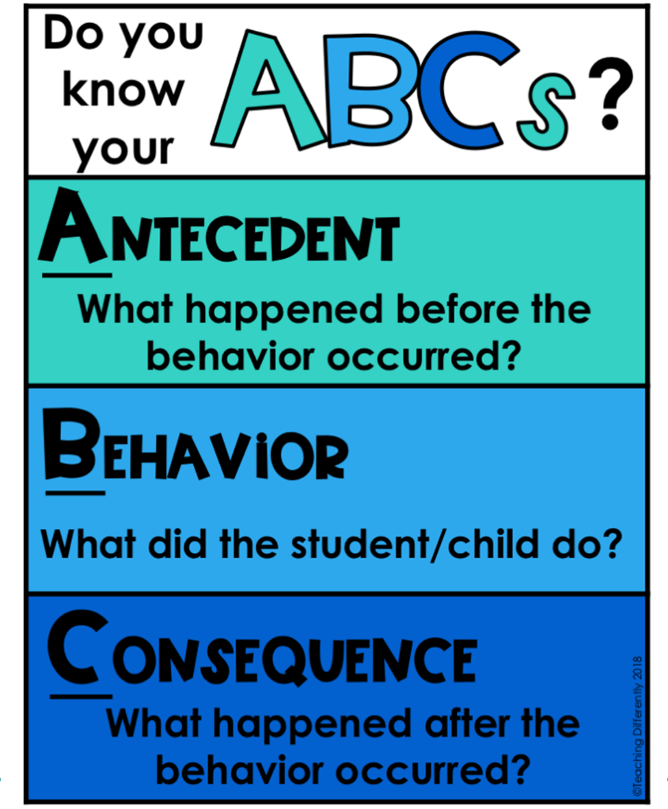
Childhood Autism Services pg. 4
Barriers to
making progress
lack of guardian
involvement
inconsistent
treatment application
innapropriate
educational placement
inability to fulfill
clinically recommended hours
Environmental
factors that affect behavior
juggling multiple
schedules
lack of
collaboration
over/under
stimulating environments

The functions of behavior are the “why” behavior is happening. For every behavior that occurs, a ‘function’ (or combination of functions) can be identified. This is the first step in determining treatment to increase appropriate behaviors and decrease inappropriate behaviors using Applied Behavior Analysis.
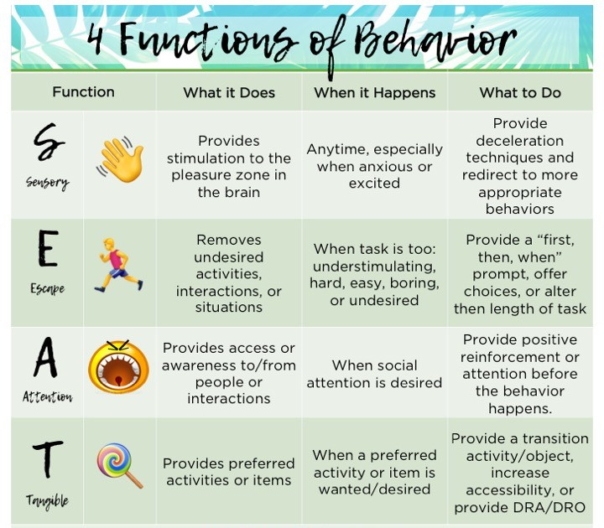

Extinction | Extinction Burst
- Extinction is when the reinforcement that was maintaining a behavior is no longer provided.  - Example: Tommy cries every time mom tells him to eat his peas. Mom eventually lets him leave the table (reinforcement) but he doesn’t get to watch TV after dinner. Extinction  = mom has Tommy sit at the table until he consumes his peas | - When using extinction, the behavior you are targeting is likely to increase in frequency, duration, or intensity temporarily. When reinforcement is no longer provided for a particular behavior, the child may display that behavior even more for a period of time.  - Example: When the father puts his child’s repeated asking on extinction, the child will most likely ask for the preferred item even more for a while to see if the dad will eventually give in. The father should continue to put the repeated asking on extinction (not give in to the behavior) and then the behavior is likely to decrease. However, it is important to note that if there is another function rather than access to the tangible item for repeated asking, simply not providing the item may not be effective. Always consider the function of the behavior.

Childhood Autism Services pg. 5

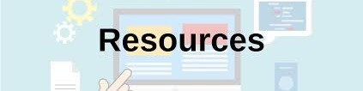

Research Articles Treatment Gains from Early and Intensive Behavioral Intervention (EIBI) are Maintained 10 Years Later
Helpful Websites: www.autismnebraska.org www.autismspeaks.org www.wrightslaw.com
www.howtoaba.com/parent-training/
Smith, D., Hayward D., Gale C., Eikeseth, S., Klintwall, L.
Books:

The Verbal Behavior Approach – Mary Barbera
Let Me Hear Your Voice – Catherine Maurice

ABA Visualized: A visual guidebook for parents and teachers – Van Diepen, Morgan Alexandra
https://www.ncbi.nlm.nih.gov/pubmed/ 31619051

The Top 10 Reasons Children With Autism Deserve ABA
Mary Beth Walsh

https://www.ncbi.nlm.nih.gov/pmc/arti cles/PMC3196209/?fbclid=IwAR2k07 q8tpDTNa1CUkc2Bmq6bbsQY8oVNp TeCgoQ6XtlKa1DJRUu38YTGr8
Free Online Training Modules

Autism Internet Modules

www.autisminternetmodules.org

Autism Focused Intervention Resources & Modules

www.affirm.fpg.unc.edu

Thompson Center for Autism and Neurodevelopment Disorders

www.thompsoncenterformissouri.edu

NE Autism Spectrum Disorders Network

www.unl.edu
Childhood Autism Services pg. 6

AUTISM-FRIENDLY COMMUNITY PROVIDERS
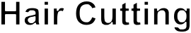

Adaptive Aquatics
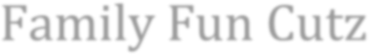
Omaha, NE 68116
Family Fun Cutz Adaptive Aquatics Omaha, NE 68116
Ph: 402-896-4280
Contact: Glen Wragge
Ph: 402-896-4280
Contact: Glen Wragge

ALL PLAY Miracle League
13414 Paul Street
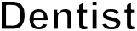
Omaha, NE 68154
Ph: 402-305-5020
Contact: Bruce Froendt Email: bfroendt@allplay.org
Smile Station
Omaha, NE 68116
Ph: 402-896-4280
Contact: Glen Wragge

ASAP Aquatics Programs
Private swimming lesson for children and adults with special needs.
Omaha, NE Ph: 402-895-7946

Challenger Little League
Kidz in Motion Dance Company “A” Team Class for Girls with ASD ages 7 and Up 3503 Samson Way, Suite 101 Bellevue NE
Ph: 402-292-2131

Metro Stars Gymnastics – Special Stars
12305 Cary Circle Suite 11
LaVista, NE 68128
Ph: 402-505-7600
info@metrostarsgym.com

Pump It Up Omaha
Autism Support Group Night 960 S 72nd St
Omaha, NE 68114-4634
Ph: 402-932-7867
PO Box 241628
Omaha, NE 68124
Ph: 402-558-0031
Email: admin@challengerlittleleague.net

Heartland Equine Therapeutic Riding Academy (HETRA)
4906 South 180 Street
Omaha, NE 68135
Ph: 402-359-8830
Fax: 866–577-4598
Contact: Edye Godden Email: Edye@hetra.org

Keys to Harmony, LLC
10925 Hascall Street
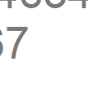
Omaha, NE 68144
Ph: 402-502-7572

Childhood Autism Services pg. 7

